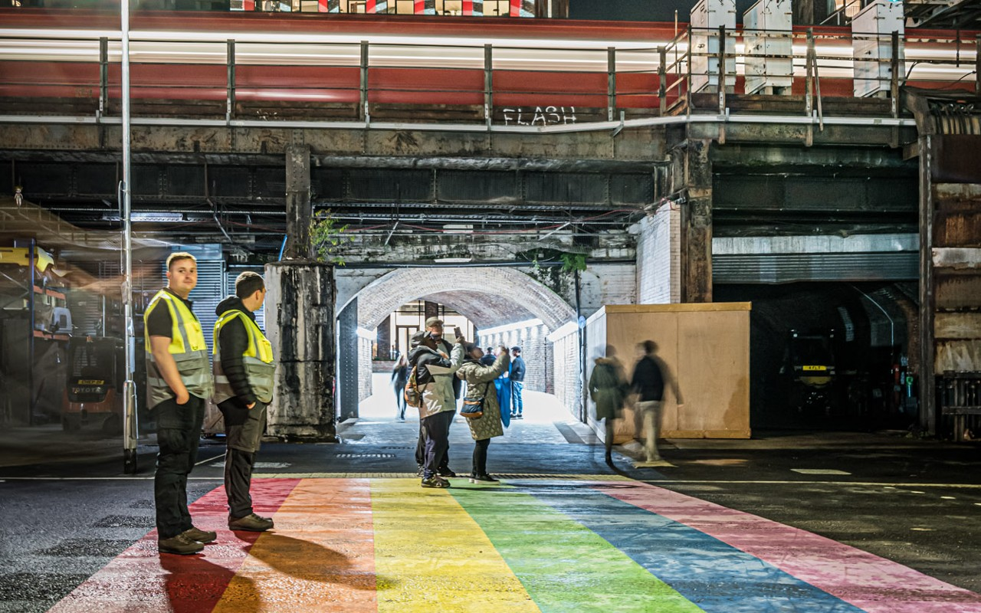
Invitation to participate in a research project to assess the impact of colourful road surfacing on autistic people
Date: September 3, 2024
Time: 11am to 12pm
Location: Online meeting
Topic: Sustrans, with support from the National Autistic Society conducting a research project to assess the impact of colourful road surfacing on people with autism.
Activities: We are seeking adults with autism to participate in a workshop on 3 September. The workshop will involve a 1 hour discussion about colourful surfacing on the carriageway, design criteria and preferences, showing some design outcomes from previous working groups.
Registration:
If you would like to take part, please register your interest by emailing adrian.hooper@sustrans.org.uk.
No prior experience or understanding of colourful surfacing is required to take part in the discussion.
For more information, please email adrian.hooper@sustrans.org.uk or call 07866 143838.

